Tab 1



**Project 3 - AI Bootcamp**

*Confident Kitchen*

Saving time and making purchasing   
decisions easier in the kitchen and home.

**I. Project Overview**

Challenge given: Design and build an ANN, CNN, LSTM-RNN, or transformer to apply in a real world application.

Team response: Create a chatbot assistant using Streamlit as the UI for the recommendation engine that uses a Question and Answering Model that feeds into an LLM to help purchase home and kitchen products on Amazon based on Amazon reviews.

Transformer (neural network)

Chatbot assistant (Streamlit)

Distilbert - Question and Answering Model – subset of data

LLM - Mistral (Prompt Engineering) – raw data

Notes

First step in embedding is tokenize

Split data into chunks

Creates vectors

**How Does Advanced ML Solve This Real World Problem?   
What Approach Will You Use?**

Solves the problem of making recommendations without sorting through hundreds of products or going through numerous reviews before making a purchase decision, saving time and receiving product recommendations that are more fitting.

**II. Meet the Team**

| Team Directory & Roles | |
| --- | --- |
| Name | Role |
| Sowmya Shetty | Technical Design,Engineering |
| Eshumael Manhanzva | Engineering |
| Luther Johnson | Technical Design, Creative Design, Documentation |
| Saurabh Singh | Engineering |
| Cameron Keplinger | Engineering, Documentation |
| Valarie Miller | Technical Design, Creative Design, Documentation, Editing |

**III. Strategy**

Identify Problem/challenge

Select data, Pre-process

Condense data set to Home & Kitchen (Apply data models)

Train neural network and show progression

Fine tune

Provide persona/”model” for chatbot to follow

Build ChatGPT chatbot experience using same dataset

Use Streamlit/Gradio to showcase experience

Test, review

Develop slide deck

Edit, review documentation (code, ReadMe, presentation)

**IV. Breakdown of Tasks & Owners**

| Project Roadmap | | | |
| --- | --- | --- | --- |
| Task | Due by | Status | OwnersPeople |
| Project Ideation, Organize team and select team lead (Find a dataset or datasets that are sufficiently large enough to effectively train a ML model or neural network with a high degree of accuracy to ensure that your results are reliable) | 3/31/2025 | Completed | All |
| Create GitHub repo for project and allow access to team members and instructional staff | 3/31/2025 | Completed | Sowmya |
| Brainstorm and identify project idea | 3/31/2025 | Completed | All |
| Begin data research and identify data sources and algorithms (Data fetching, data exploration) | 3/31/2025 | In progress | Data source is identified |
| Create project proposal | 3/31/2025 | In progress | Draft completed - Valarie |
| Data prep and initial analysis needed to evaluate the performance | 4/1/2025 | Not started | Sowmya, Eshumael, Saurabh, Sowmya, |
| Coding (data transformation, data cleansing,) | 4/1/2025 | Not started | Sowmya, Eshumael, Saurabh, Cameron, Luther, Valarie |
| Coding (testing ML models, integrating AI tools), documentation (Evaluate the trained model(s) using testing data. Include any calculations, metrics, or visualizations needed to evaluate the performance) | 4/3/2025 | Not started | Cameron  –note–evaluate performance–  Include F1, Blue score  F1 – as combination of precision and recall |
| Create chatbot UI | 4/7/2025 | Not started | Person |
| Coding, documentation | 4/7/2025 | Not started |  |
| Presentation prep | 4/8/2025 | Not started | All |
| Practice run through | 4/8/2025 | Not started | All |
| Presentation Day | 4/10/2025 | Not started |  |
| Project files due | 4/10/2025 | Not started |  |

**V. Datasets and Models to Be Used**

* Large-scale dataset:<https://amazon-reviews-2023.github.io/#grouped-by-category>
* Q&A - Distilbert (Hugging Face)
* Text Summarization - part of LLM
* Translation - part of LLM (not sure)
* LLM

**VI. Requirements (not identified above)**

Must use two of the following:

* Scikit-learn
* Keras
* TensorFlow
* Hugging Face * (used)
* spaCy or NLTK (Natural Language Toolkit)
* LangChain * (used)
* OpenAI

Must use one additional library or technology not covered in class such as:

* VADER (Valence Aware Dictionary for Sentiment Reasoning)
* Whisper (OpenAI’s automatic speech recognition system)
* DALL-E (Open AI’s text-to-image model)
* PyTorch - used
* RAG (augmenting knowledge base with own database – called RAG) - used and used vector data stores (RAG = Retrieval augmentation)

Other OpenAI capabilities including:

* Text-to-speech
* GPT-4 with vision (GPT-4V)

**VII. Grading** *(Each 25 pts.)*

* Implement model with appropriate pre-processing and data cleaning.
* Optimize model and display the performance.
* Document your project using a well formatted GitHub README.
* Present finding in a slideshow presentation.

Overview



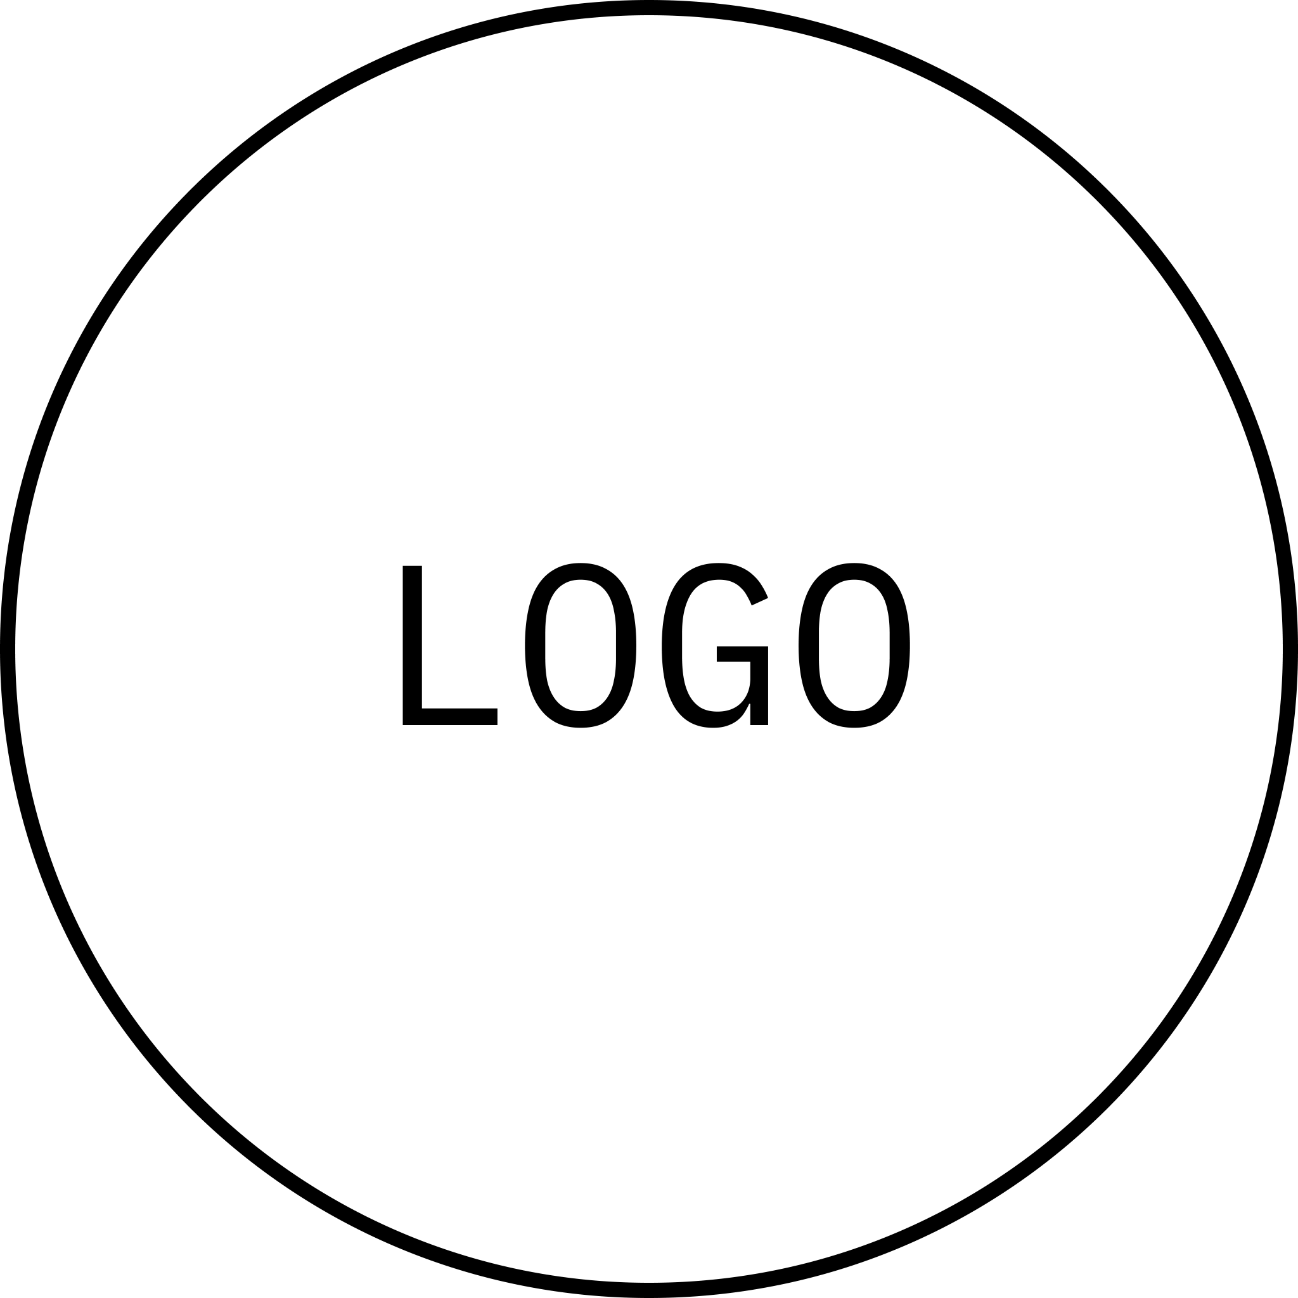

Account plan

# EXECUTIVE SUMMARY

#### Add an executive summary. This summary should start with a succinct overview of the company and client, highlighting core challenges and opportunities. Clearly articulate primary goals, ensuring they are measurable and have specific targets. Briefly summarize the key strategies designed to achieve these objectives. Incorporate a concise analysis of the competitive landscape and emphasize your company's unique strengths. Conclude with a high-level financial projection and a compelling call to action, encouraging stakeholders to review and support the plan.

# ACCOUNT OVERVIEW

| Account information |  |
| --- | --- |
| Name | Person |
| Email | Email address |
| Phone number | (000) 000-0000 |
| Address | Place |
| Communication preference | Phone |

| Past and current sales | |  | Future opportunities | |
| --- | --- | --- | --- | --- |
| Product | Value |  | Product | Value |
| Product name | $000/month |  | Product name | $000/month |
| Product name | $000/month |  | Product name | $000/month |
| Product name | $000/month |  | Product name | $000/month |

# HEADWINDS / BLOCKERS

* Identify potential challenges or obstacles that may impede progress towards achieving the account objectives
* Consider internal factors within the account, such as budget constraints, decision-making processes, or existing vendor relationships
* Account for external factors, such as competitive landscape, market trends, or regulations
* For each identified headwind or blocker, outline potential mitigation strategies or contingency plans

# REQUESTS

* Define requests or actions needed to advance the account strategy
* Include requests for internal resources, such as personnel, budget, or marketing
* It may also entail requests directed towards the account, such as access to key decision-makers, participation in specific events, or collaboration on joint initiatives
* Ensure that each ask is specific, measurable, achievable, relevant, and time-bound

Background

# BACKGROUND

## History with the company

In a paragraph or less, provide an overview of the history with this company. This could include interactions, key events, communications, and milestones.

## Key decision-makers

| Name | Title | POC | Contact information | Notes |
| --- | --- | --- | --- | --- |
| Person | Title | Person | Add information | Add notes |
| Person | Title | Person | Add information | Add notes |
| Person | Title | Person | Add information | Add notes |

## Current product and services

* List the types of products and services this customer prefers
* Preference 2
* Preference 3

Account strategy

# ACCOUNT STRATEGY

Indicate how the account strategy plan aligns with the overall goals of the account. Explain how the strategy will be used to pursue specific initiatives to help achieve company goals.

| ACTIONS | RESOURCES | METRICS | DUE DATE | OWNER |
| --- | --- | --- | --- | --- |
| Add action | Add resources | * Metric 1 * Metric 2 | Date | Person  Person |
| Add action | Add resources | * Metric 1 * Metric 2 | Date | Person  Person |
| Add action | Add resources | * Metric 1 * Metric 2 | Date | Person  Person |
| Add action | Add resources | * Metric 1 * Metric 2 | Date | Person  Person |
| Add action | Add resources | * Metric 1 * Metric 2 | Date | Person  Person |

Competitive and SWOT analysis

# COMPETITIVE ANALYSIS

## Describe their competitors

* List companies offering similar products or services. Be specific and include large and small competitors.
* Consider alternative products or services that might meet the same customer needs

## Summarize their competitive advantage

* Clearly articulate how your client differentiates itself from the competition
* Highlight market opportunities
* Support the competitive advantages with data whenever possible

| INNOVATIVE | | | |
| --- | --- | --- | --- |
| HIGHER PRICE | Competitor | Company Competitor Competitor | LOWER PRICE |
| CompetitorCompetitor | Competitor |
| CONVENTIONAL | | | |

# SWOT ANALYSIS

| Strengths | Weaknesses |
| --- | --- |
| Internal factors that give the account a competitive advantage.  Focus on unique capabilities, resources, or market position.  Examples: Strong brand reputation, innovative products, loyal customer base, efficient operations, skilled workforce. | Internal factors that can hinder the account's progress.  Identify areas for improvement or potential vulnerabilities.  Examples: Limited market share, outdated technology, high costs, lack of skilled personnel, weak distribution network. |
|  |  |
| Opportunities | Threats |
| External factors that the account can use for growth or improvement.  Identify emerging trends, market gaps, or favorable conditions.  Examples: New market segments, technological advancements, changing regulations, economic growth, competitor weaknesses. | External factors that can negatively impact the account.  Identify potential risks and challenges.  Examples: Intense competition, economic downturn, changing customer preferences, disruptive technologies, regulatory changes. |

Interaction log

# INTERACTION LOG

| Date | POC | Type of interaction | Notes | Next steps |
| --- | --- | --- | --- | --- |
| Date | Person | Meeting | *Interested in new product* | Ongoing |
| Date | Person | Phone call | Notes | Resolved |
| Date | Person | Email | Notes | Escalated |

# ACTION ITEMS

| Action item | Assigned to | Deadline | Status |
| --- | --- | --- | --- |
| *Send customer new catalog* | Person | Date | Completed |
| Action item 2 | Person | Date | Completed |
| Action item 3 | Person | Date | Completed |

# MEETING NOTES

*To add a meeting notes building block, type “@meeting notes”. Search for or select a meeting to add attendees, notes, and action items.*

Executive summary



Case study title

Executive summary

# Overview

### *Summarize the project*

In 1-2 paragraphs, succinctly summarize the project, identifying both the client and company. Outline the project's scope and then clearly articulate the client's core problem or desired outcome.

Briefly explain the main solutions, emphasizing any novel or creative approaches taken. To illustrate the project's success, provide concrete numbers or outcomes. Conclude with an impactful sentence that illustrates the project’s key takeaway or value proposition.

| A pink and purple circle with a green ball in balancing on the left bottom part of the ring. |  | Key findings*Identify the project’s most noteworthy findings*  * 1. Key finding 1   2. Key finding 2   3. Key finding 3 |
| --- | --- | --- |

| Solutions*Document solutions that were developed*  * 1. Solution 1   2. Solution 2   3. Solution 3 |  | Peach sphere coming out of a tube on a balancing see saw. |
| --- | --- | --- |

| a white ball on a striped blue surface |  | Impact*Summarize the project’s greatest areas of impact*  * 1. Impact 1   2. Impact 2   3. Impact 3 |
| --- | --- | --- |

Introduction & recommendations

# Introduction

## Background

### *Provide context for the project*

Provide an overview of the project, including its origins, client, goals, and impact. Describe the leading company or individual, highlighting relevant qualifications and past successes. This section can include more depth and context for the reader.

## Objectives

### *State the case study goals and objectives*

* 1. Objective 1
  2. Objective 2
  3. Objective 3

## Problem

### *Outline what motivated the project*

Share the primary problem, challenge, or opportunity that the project aimed to address. Clearly articulate the issue or need that motivated the project. The length of this section is based on the complexity of the problems addressed in the project.

# Recommendations

### *Outline the solutions, strategies, or recommendations proposed to address the problem or achieve the project's objectives*

1. Recommendation 1
2. Recommendation 2
3. Recommendation 3

## Impact of recommendation

|  | **SOLUTION** | **EFFECTIVENESS** | **IMPACT** | **NOTES** |
| --- | --- | --- | --- | --- |
|  | Recommendation 1 | Highly effective | Add impact notes | Add additional context |
|  | Recommendation 2 | Ineffective | Add impact notes | Add additional context |
|  | Recommendation 3 | Marginally effective | Add impact notes | Add additional context |

Analysis

# Analysis



## Research methods

### *Note the methods used to gather data for the case study*

Many case studies use a mixed-methods approach that combines qualitative and quantitative data collection techniques. The level of detail in this section depends on the audience for the case study.

## Approaches used

### *Outline the specific approaches or frameworks used*

Framework could include theoretical models, industry standards, or best practices. Theoretical models help people understand the situation. Industry standards and best practices can help evaluate performance, gain insights, and identify areas to improve.

## Relevant facts and information

### *Present key facts*

* 1. In a few bullet points, present key facts, figures, and information that surfaced during analysis, such as: project specifications, timelines, budgets, or other quantitative data
  2. Describe how those facts relate to the problem statement
  3. Include specific sources and data points where possible

Conclusion

# Conclusion



## Summary of findings

### *Summarize the main findings or conclusions of the case study*

This should be a more comprehensive summary, taking the whole project into consideration and incorporating key findings from the entire document. Use multiple paragraphs if necessary.

## Implications of the study

### *Describe the impact of the completed study*

Focus on real-world impact, concrete outcomes and how they addressed the project’s goals. Evaluate outcomes using both objective data and subjective feedback. Draw well-supported conclusions based on analysis and interpretation of relevant information.

#### **“Feature a quote from the case study. It should be a key takeaway or learning that you want audiences to remember.”**

If your implications explanation is lengthy, you can break it up with a quote to help communicate a key takeaway.

References

# References

### *Check what reference style your organization typically uses. Below is an example of the format for citing references called APA. Other common formats include MLA and Chicago Style.*

##### Examples:

Lastname, A. (Year). *Book Title*. Publisher. DOI

Lastname, A., Lastname, B., & Lastname, C. (Year). Article title. *Journal Title, Volume#*(Issue#), Page(s)#. DOI

Lastname, A. (Year, Month Day). *Title*. Site Name. URL

## Supplementary materials

|  | **FILE** | **NOTES** |
| --- | --- | --- |
|  | File | Files might include surveys, questionnaires, or data tables |
|  | File | Add file notes |
|  | File | Add file notes |